Web Application Documentation: PennsyPedia

**Developer Names:**

Mehak Manwani (mmanwani)

Medina Ali (medina)

**Web Application URL:** <http://nodejs-medinatest.rhcloud.com>

**API Documentation URL:** <http://www.worldweatheronline.com/api/docs/local-city-town-weather-api.aspx>

**Web Application Description:**

This Web Application is designed to allow users to retrieve weather information about all the cities of Pennsylvania by entering the city name. This web application uses AJAX request system to retrieve specific weather information from World Weather Online (<http://www.worldweatheronline.com> ) as it provides a public API. The interactions that take place between the user and this web application is described in the process below:

Process

1. The loaded page below shows the interface of our web application that consists the 3-interaction points.

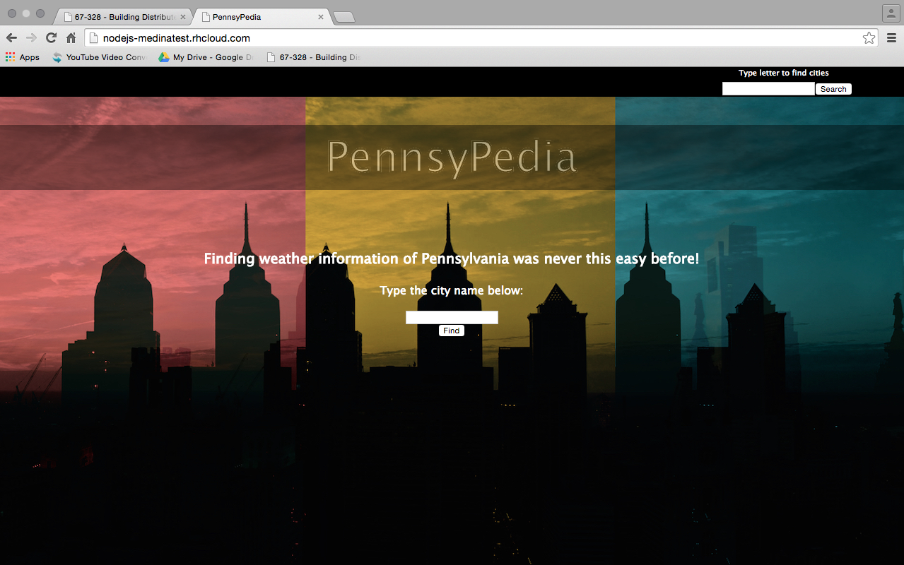

2. The first interaction point is where the user enters a city name to **find** (retrieve) the weather information.



(If the user, is not aware of the correct city name, he / she can use the search option in the header to retrieve city names through alphabets)

3. The second interaction point is where the user may **search** city names by entering any letter of their choice.

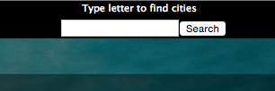

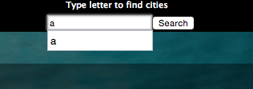

4. This an example of the output, when the user enters an alphabet, for instance “a”.

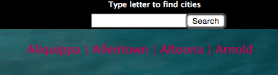

5. However, if the user enters more than one letter an **alert** message shows up to prevent users from using abbreviations.

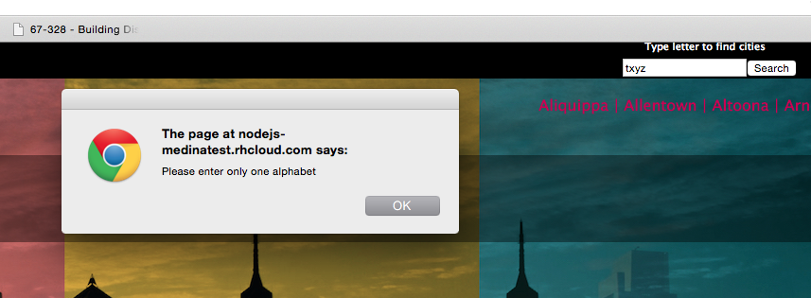

6. If the user knows the name of the city he / she wants to retrieve weather information about, he/she can simply enter it as shown below:

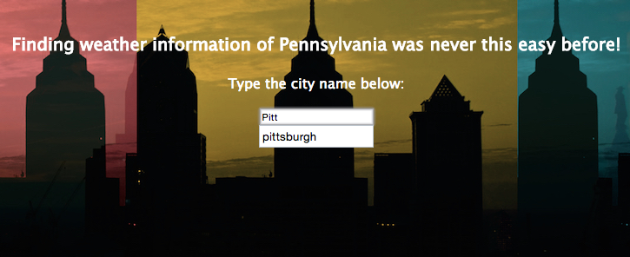

6. Having clicking Find, displays the city name along with its current weather condition.

**(AJAX request made here)**

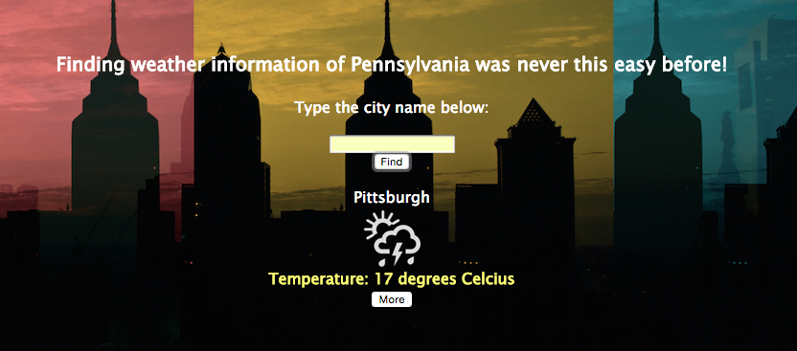

(This brings up the 3rd point of interaction)

7. This is the 3rd point of interaction, where if the user clicks **More**, he / she can retrieve more information about the selected city’s weather.

**(AJAX request made here)**

Macintosh HD:Users:medinaali:Desktop:Screen Shot 2015-09-30 at 2.48.01 AM.png

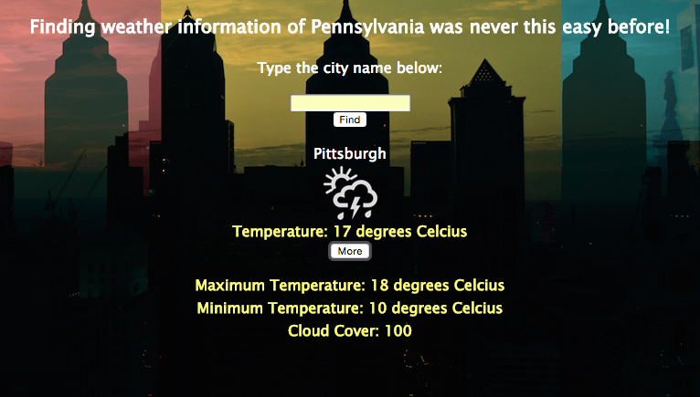

(The user can toggle between the information by clicking the More button as many times as possible)

8. In addition to the 3 interactions, the web application consists of a contact feature in the footer, which uses the mailto method that allows users to interact by redirected email. It is demonstrated below:

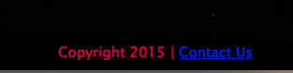

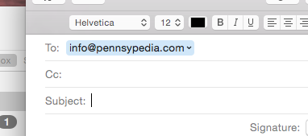

**jQuery Methods used:**

1. .css()
2. .click()
3. alert()
4. .hide()
5. .show()
6. .slideUp()
7. .mouseenter().fadeTo()
8. .mouseover().css()
9. .slideToggle()
10. .prepend()

The jQuery methods mentioned above has been used in the Web Application for sophistication of functions. For example:

The mouseenter().css() function has been used in the footer, where the background color changes from Black to Light Grey when the mouse hover overs the footer.



Macintosh HD:Users:medinaali:Desktop:Screen Shot 2015-09-30 at 2.41.15 AM.png

Again,

The mouseenter().fadeTo() methods have been used to achieve the following, where the opacity changes when mouse enters the specific div.

